# PEOPLE

# RESEARCH ASSISTANT

Ms Elena Theori

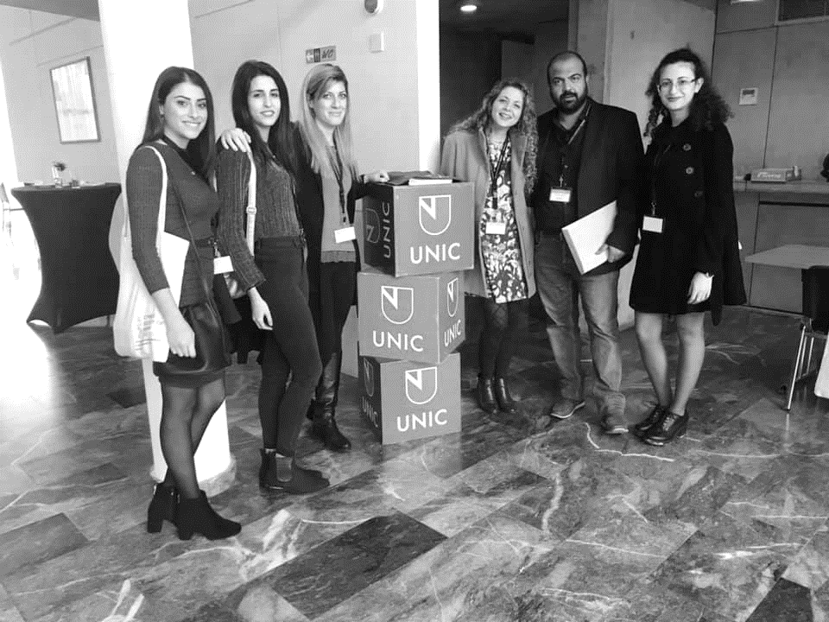Elena holds a BA in Human Biology from the Department of Life and Health Sciences of the University of Nicosia.

Elena is carrying out a number of techniques in the lab such as: RT-qPCR, RT-PCR, Mammalian cell culture (CaCo2, SW-620 and SW480), Transfections, Cell functional assays (MTT, Scratch assay), DNA Cloning in Bacteria, Sequencing and she is also supervising undergraduate students enrolled in various projects in the lab. Research-wise, Elena is interested in microRNA biology and its effect in carcinogenesis.

Her poster presentation entitled: ‘Bovine specific miRNA, bta-mir154c, can survive human digestion and affect cancer-related processes in Colorectal Cancer cell lines’ during the 7th International Conference of the Cyprus Society of Human Genetics was awarded the Best Poster Award.

Elena is also very active in Science Communication and has participated in various outreach events such as the European Researcher’s Night and the 1st Mediterranean Science Festival.

# Interests

Bovine microRNAs

Colorectal cancer

Human Digestion

# Undergraduate student

Ms Erato Christofidou

Erato is a 4th year undergraduate student in the Human Biology program at the Department of Life and Health Sciences of the University of Nicosia.

Erato is involved in a project concerning the Science Literacy determination among Science and non-Science majors studying at the University of Nicosia, Cyprus supervised by Dr. Myrtani Pieri.

Elena is also very active in Science Communication and has participated in various outreach events such as the European Researcher’s Night 2018 and 2019.

# Interests

Science literacy

Biology education

# Undergraduate student

Mr George Iliadis

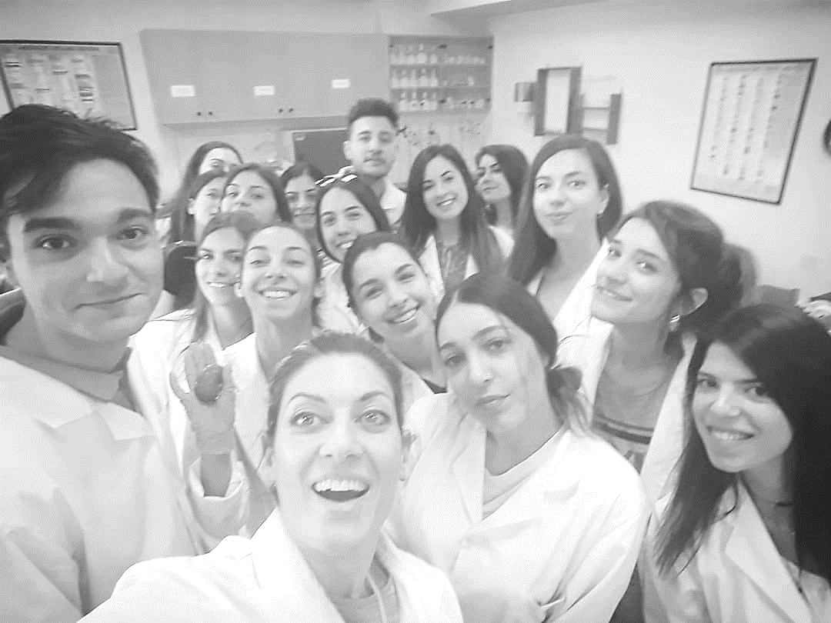George is a 4th year undergraduate student in the Human Biology program at the Department of Life and Health Sciences of the University of Nicosia.

George is involved in the MicroFOOD project and specifically he is studying the effect of ingested microRNAs on the human microbiome. George is carrying out a number of experiments to examine whether Cy3-labeled bta-miR154c miRNA is taken up E. coli when co-cultured.

Data will be valuable on assessing whether ingested miRNAs mediate inter-species control of the human gut microbiota.

This project is co-supervised by Drs Myrtani Pieri and Vicky Nicolaidou.

Methods/Techniques: Bacterial culture, Confocal microscopy and Flow Cytometry

# Interests

Ingested microRNAs

Inter-species interaction

Microbiome